Set II
Section A
I Prove that the Resolvant set δ(T) of bounded linear operator T on Comlex Banach Space is Open and hence spectrum σ(T) is bounded.
2 State and Prove Spectral Mapping Theorem.
3 If X≠ {0} Complex Banach Space and T B(X,X). Prove that Spectrum σ(T) 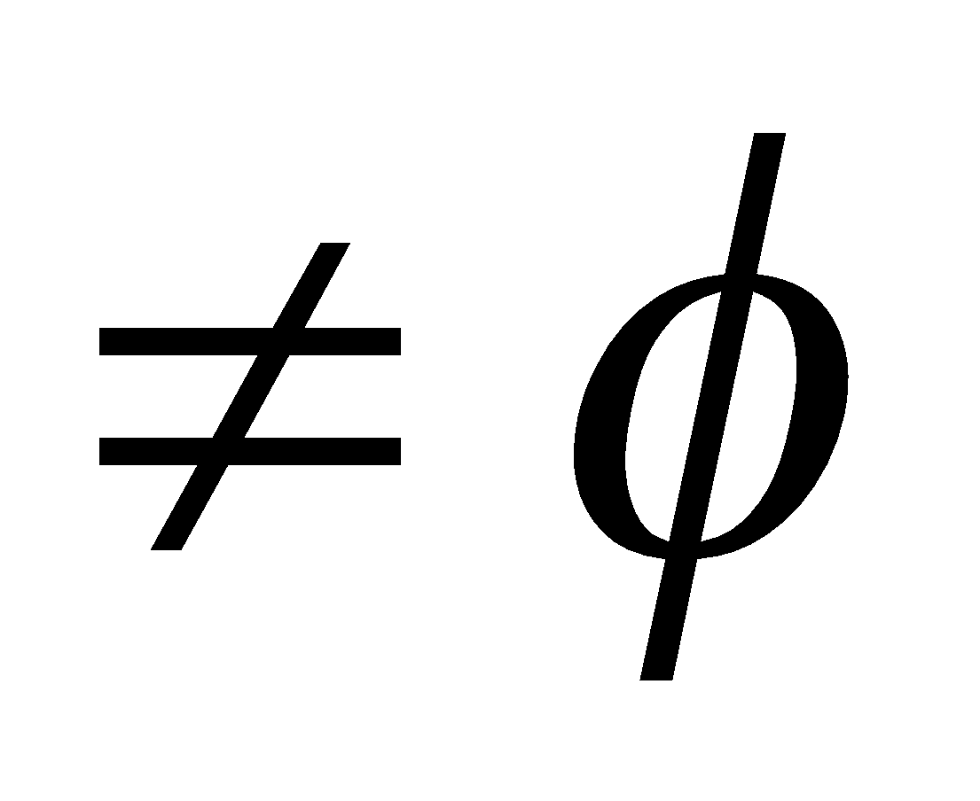 .
4 let A be Complex Banach Algebra with Identity e .then for any x  A. the Spectrum σ(x) is compact and Spectral Radius r _{σ} (X)≤ ║X║
Section B
5.Define Compact Linear Operator. State and prove Compactness Criteria.
6. Let X be a Banach space , T is a compact linear operator on X. Prove that every spectral value 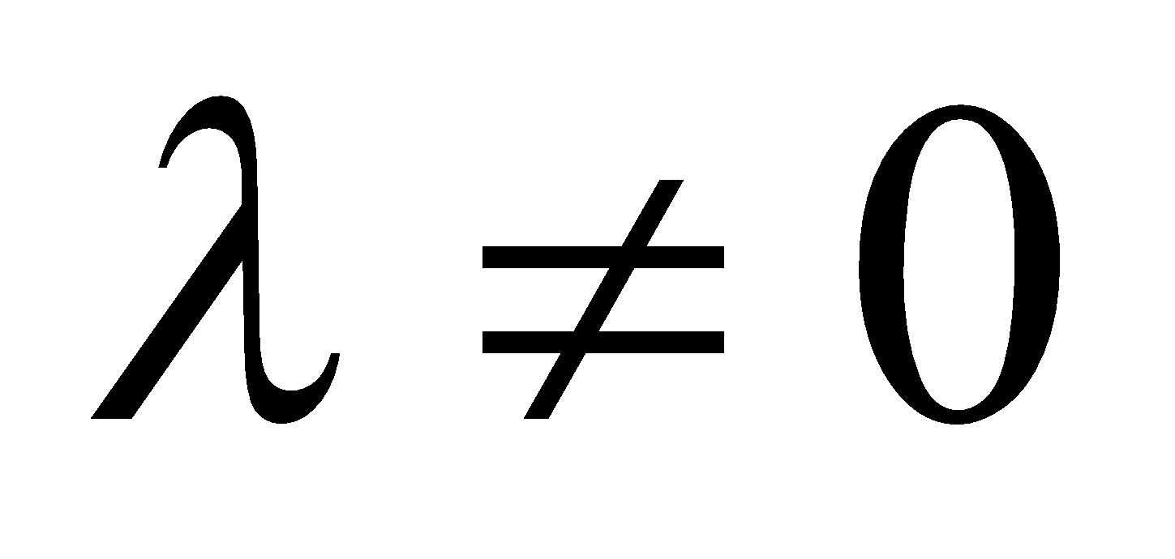 of T is an eigen value of T.
7. Let H be a Complex Hilbert space and T be a bounded self adjoint operator on H. then a number 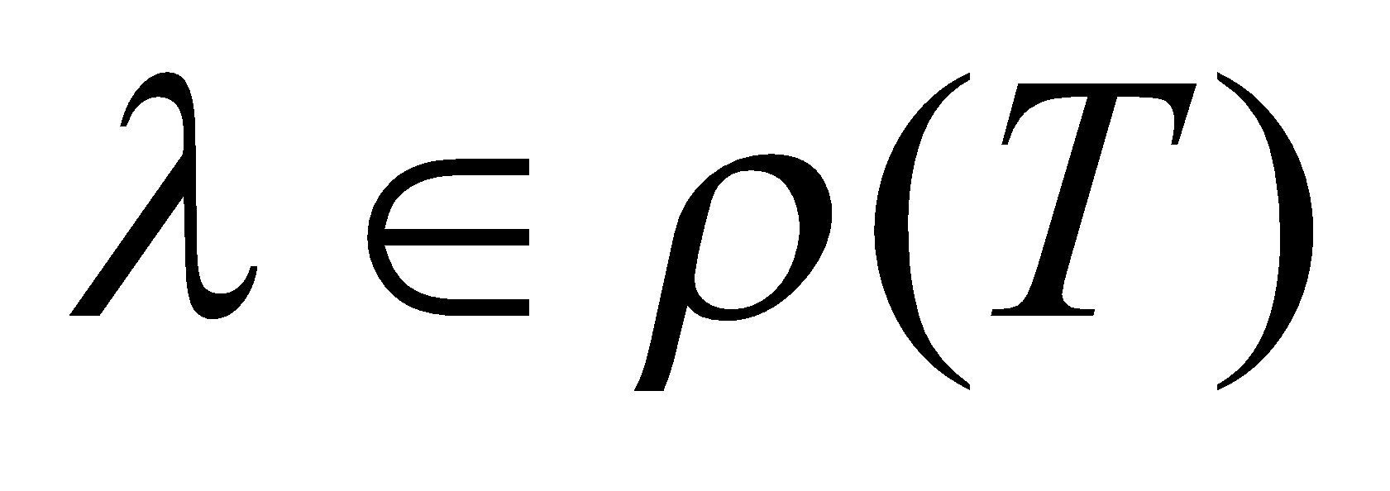iff 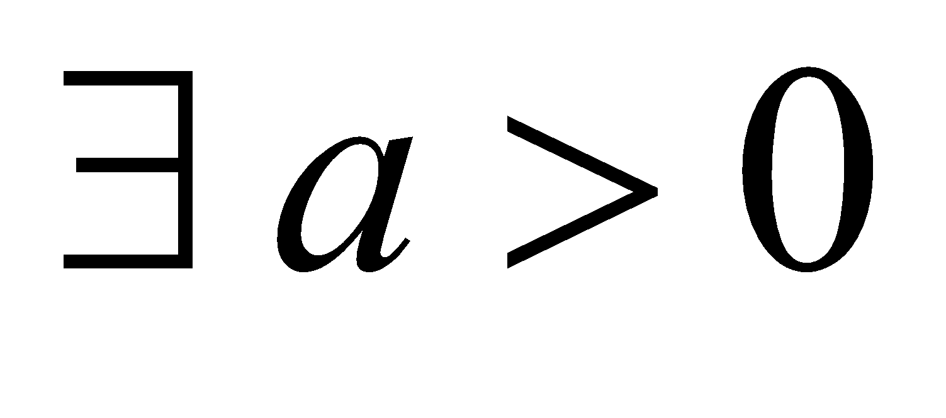 such that 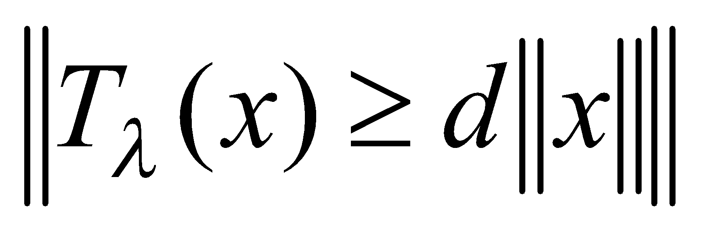 for all 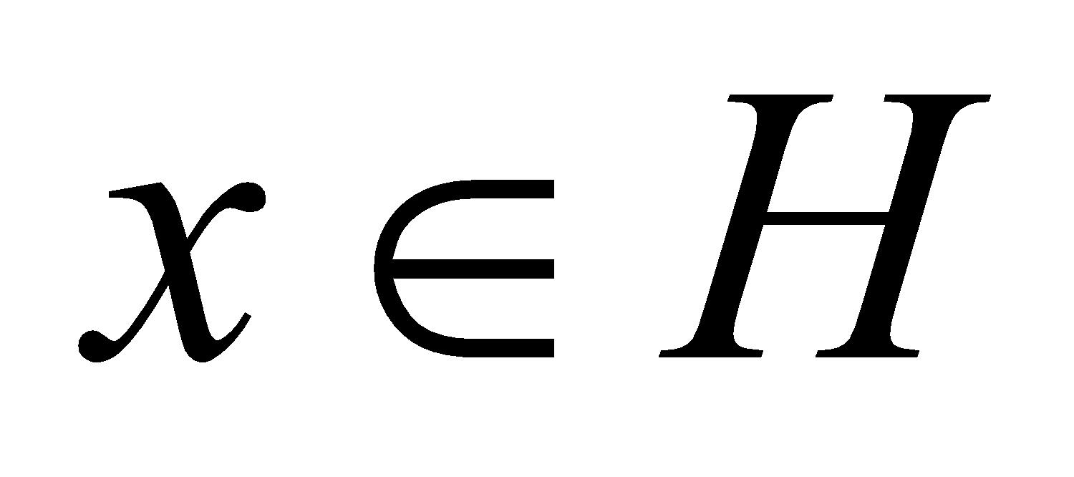.
8. Let T: X→Y be a linear operator if T is compact then prove that adjoint operator T *:Y'→X' is also compact .(where X and Y are normed spaces and X' and Y’ are dual spaces of X and Y respectively.
Section C

9. Attempt all questions:
- Define Spectrum and its types.
- Let T : X→X be a compact L.O on a banach space X then every spectral value of T is an Eigen value.
- Prove that ST and TS are compact if T is bounded and S is compact.
- Every Compact linear operator is continuous .Is converse true.
- Define Projection.
- Define Fredholm alternative
- Define Positive operator.
- Define weakly convergent sequence
- Let T and S be compact and bounded linear operator on a normed space X. Prove that TS and ST are compact.
- State spectral closed theorem.

